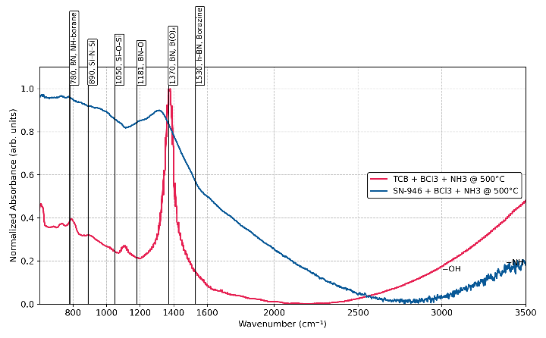
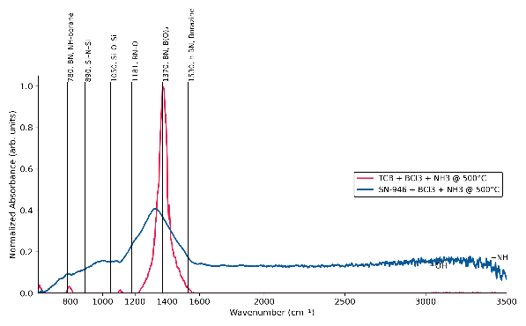
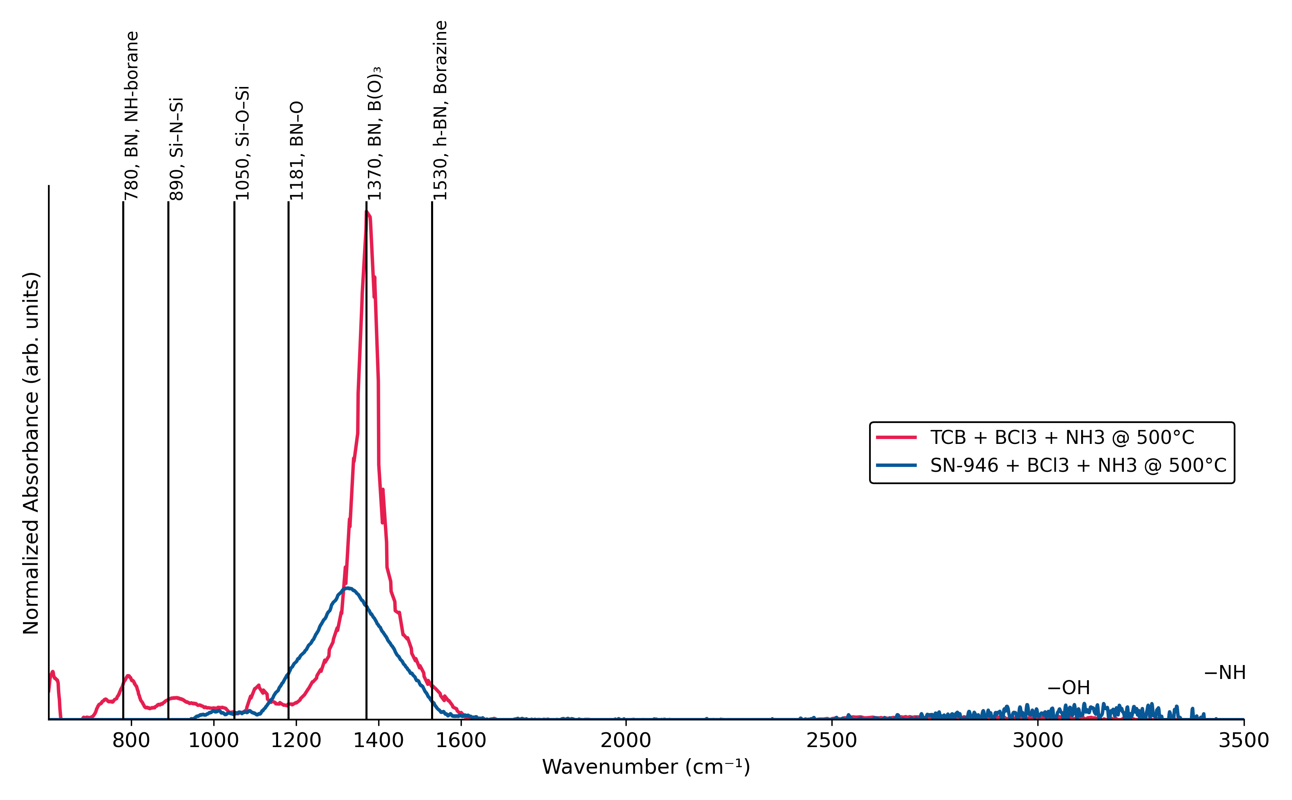
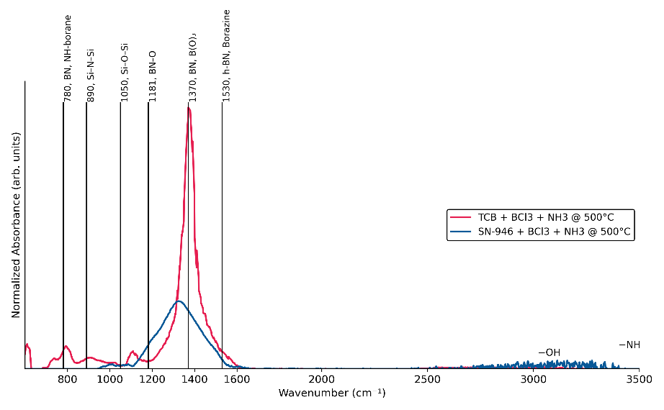
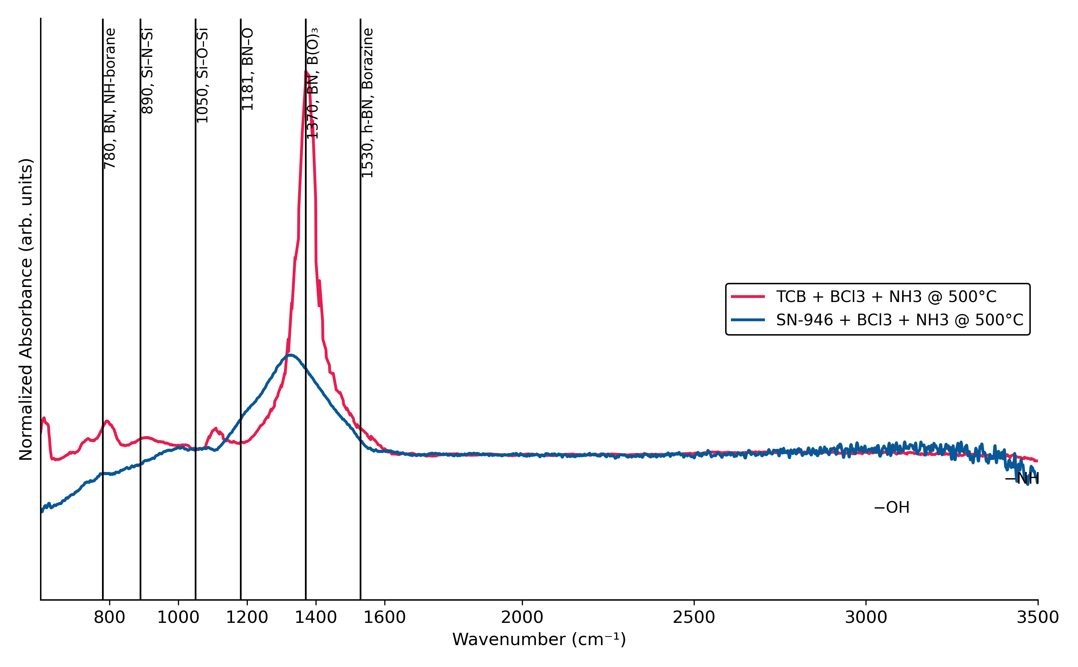
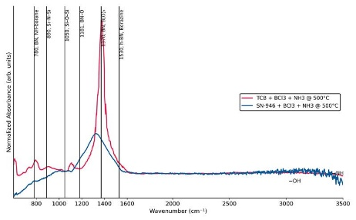
Title of Presentation | DD.MM.YYYY
58
- please plot the excel FTIR data like this which exactly labeled formating !
- ok great ! please label y normalized absorbance arb.units and use these colors rgb(230, 30, 80) for TCB and it should be normalized to largest y axis dimensions of that peak and use rgb(8, 88, 151) for the SN_946 and the labels need to be swapped! The bigger peak blue one currently is the TCB. Also plesae label the peaks and x axis should start when the x data starts and end at 2500
- ok things that are wrong 1. the y shouldn't have tick marks and values 2. the x axis starts where the data starts and ends at 3500 cm your's is flipped! 3. you need to look at the TCB highest y value and normalized from that 4. the peaks should be label like the figure too the BN NH-absorbance Si-N-Si Si-O-Si BN-O and BN, B(O)3 and h-BN, Borazine and include the conditions.
- something not correct the blue line looks shifted, and it should be labeled like this has lines also the background doesn't look right the data needs to start at zero both of the spectrum the y axis valyes
- ok that looks much better this is close but remeber how the original the plots have the same baseline? Open the raw spectrum: Load your FTIR data. Select Baseline Points: Manually pick points on the spectrum that do not have peaks (i.e., areas that should be at 0 absorbance or 100% transmittance). Apply Fitting Function: Use a polynomial or spline function to fit these points. Subtract: Subtract the fitted function from the original spectrum to produce a flattened, corrected spectru
- ok pretty close but remeber example i sent the ? We don't need to include value labels on the ticks in y dimensions those are arb units. Also see how both lines don't have the same y value from 1700-3500 that isn't correct not the right baseline correction. This is FTIR data (turned on web search)
- ok close but can you shift the graph up so we can see all the data? Not sure how much because i can' see the y units but maybe like 10% enough that you see all the data on the plot/
- needs to be shifted more i see can't see all the data on the graph. the bottom data is being hidden you need the y axis to start at a lower value. in other words the y min need to be lower
- ok that is good but but now too much shifted! the baseline should be approx the y min see example figure

